[On 60 GHz]

New blog post from Mobile World Congress

7 March 2018

https://www.siversima.com/news/mobile-world-congress-2018/
Mobile World Congress (MWC) is the world’s largest gathering for the mobile industry, organized by the GSMA and held in the Mobile World Capital Barcelona, 26 February – 1 March 2018. Sivers IMA prefers to use a private room where we have meetings with invited guests. In this way, we can share relevant information with our customers without revealing important and confidential information to the competitors. This year we had an extensive demo showing three connected 60 GHz nodes, using our best in class WiGig RF module with the IDT Rapidwave modem platform (see picture below of one of the nodes).One of the 60 GHz nodes in the demo with Sivers WiGiG RF and IDT Rapidwave modem providing 4.6 Gbps gross data traffic and 3 Gbps throughput
We had approximately 30 meetings in the demo room and many more at our customers’ and partners’ booths. In total we had approximately 50 different relevant meetings within the eco-system. On top of this, we also grabbed the opportunity to look at the overall market message, as well as what our partners, customers and competition were showing. Below we like to give our view of the state of the 60 GHz WiGig and 5G (28-39 GHz) infrastructure market.
60 GHz WiGig (802.11ad) infrastructure solutions
It is clear that our focus on delivering a true 60 GHz WiGig infrastructure RF solution is the correct strategy. We get feedback from the market that we have the right solution and that some of the current CMOS solution, initially made for consumer electronics, is not able to deliver on their promises, having issues with meeting the wanted output power levels as well as industrial grade temperature requirements (-40 to +85 degrees Celsius). Also, another issue is the lack of robustness against interference, which happens when you try to reach > 300 meters with a solution that was built for 10 meters. For example, our customer CCS has had a tremendous pull for its 12 Gbps, 60 GHz Metnet node, which was launched at MWC. CCS’s node addresses all off the above issues which has resulted in great attention. Being able to showcase Sivers IMA RF module in a real product, is of course invaluable. Doing this with CCS with its well-known and globally recognized Metnet self-organizing system has been of great value to Sivers IMA. Also, what is worth noticing is that Sivers IMA RFIC is still the only chip covering the 66-71 GHz part of the FCC V-band, which is a unique selling point for our solution. It is not just that we can offer 5 GHz extra bandwidth, it is also the best part of the 60 GHz band when it comes to getting the best reach in meters.
Also, our partnerships around WiGig (and 5G) are very important factors, where one of the big “Wow-Factors” has been the RF-module that Fujikura now can show with our RFIC. There was many Wows uttered by people who saw this module. Below you can see some pictures of this module and how thin the antenna module is, it is less than 1 mm thick (see below).
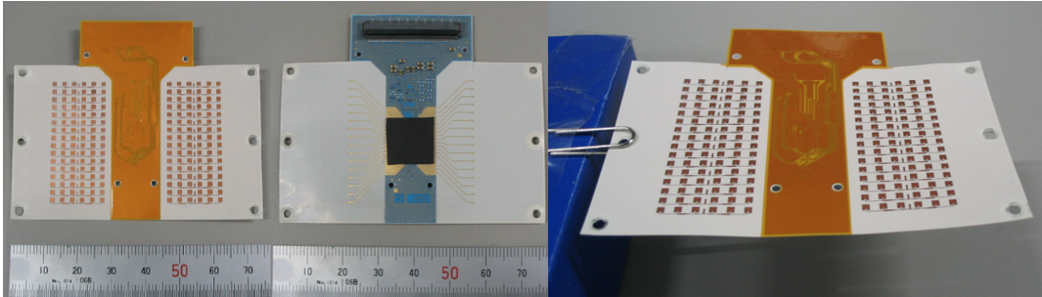Fujikura 60 GHz LCP antenna module with Sivers IMA 60 GHz RFIC
With Sivers IMA 60 GHz RFIC and Fujikura LCP based antenna, the total link budget is approximately 125-130 dB which gives a total distance of approximately 400-500 meters (at 69 GHz, Rain zone E, 99,99% availability, 1-2 GHz bandwidth). As you can see in the graph below, the atmospheric absorption is even less for 5G frequencies at 28 GHz, hence the distance would be even longer for 5G frequencies at 28 GHz (attenuation is 0.15 dB/km vs 2 dB/km).
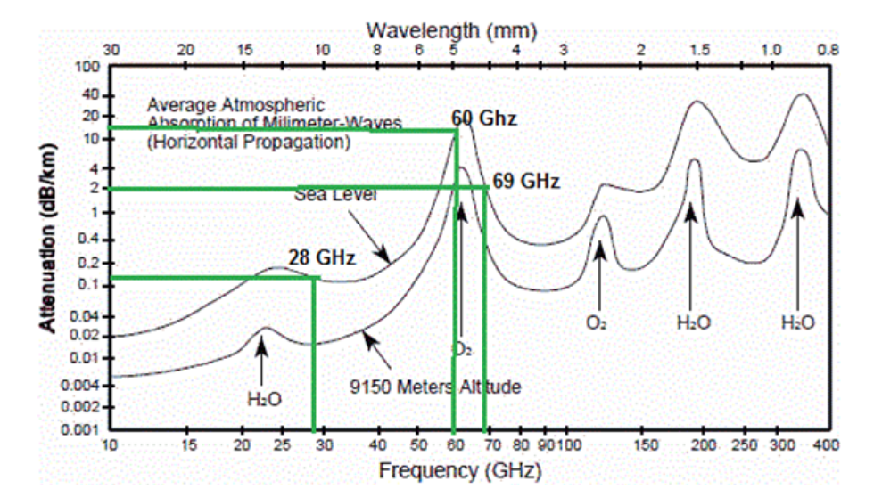Atmospheric absorption[*] of millimeter waves: 28 GHz = 0.15 dB/km, 60 GHz = 15 dB/km, 69 GHz = 2 dB/km
[*Absorption by the atmosphere occurs when gaseous molecules with permanent dipole moments couple the electric or magnetic components of the microwave field to their rotational energy levels. Most of the absorption due to excitation of collision-broadened lines occurs at the 22-GHz line of water vapor and 60-GHz line of oxygen.]
This all result in that our joint active RF beam steering antenna module with 16 transmit and 16 receive channels can transmit data at distances up to 500 meters using less than 5-watt* DC power at a very attractive cost level. This is possible due to the very high integration level of the Sivers IMA RFIC, which result in very few 3rd party components on the module, see the middle module picture, where you can see only a few passive components on the
module. And of course, also due to the low-cost Fujikura LCP material, which we only can access due to our partnership with Fujikura, we can differentiate the solution compared to the more standard type patch antennas, which both we as well as other companies offer using other substrates than LCP. When getting down to this level of detail, you will start to understand the “Wow-Factor” of this solution. Since the same type of solution can be applied on 5G (28-39 GHz), we see opportunities also in the 5G mm-wave market, where we will address the second generation 5G RF-systems with a very compact and attractive solution. This brings us over to the second big buzz at MWC 2018, 5G!
5G at MWC 2018
As in 2017, 5G was the biggest buzz word at MWC. There are now a lot of things happening and the first trial systems are rolling out to the market in the US. Before we go into this, it is important to understand that 5G will not only run on mm-Wave, there will also be a macro coverage using sub 6 GHz 5G, which might be the biggest part of the 5G market. Even so, it is still too early to tell what the distribution between sub 6GHz and mm-Wave will be. I will talk about mm-Wave since this is where our focus is. Verizon Wireless (149 million customers), the biggest operator in the US, and China Mobile (887 million customers), the world’s biggest operator, are both testing mm-Wave 5G. These two large operators have different views and time plans. The main difference is that Verizon has already started trials in many cities for Fixed Wireless Access (FWA), which is the first use case for mm-Wave 5G. Verizon is using a Pre-5G standard and want a quick rollout to real customers starting already in 2019, while China Mobile sees a slower roll-out using the 5G-NR 3GPP standard with the main build-out in 2021. Verizon is using first generation 5G systems and seems to be happy with the current results of their tests, while China Mobile would like to see lower cost systems as well as lower power consumption. Of course, covering the Chinese population with small cells using mm-Wave would be costly, hence it is understandable that the second-generation mm-Wave 5G systems are required to address these issues. Addressing these second generation 5G systems is where we believes that our 5G consortium with Fujikura and Ampleon will be in the best possible position to offer both power efficiency and performance for each possible mmWave 5G use case. For example, bringing our highly integrated 60 GHz RFIC chip to 5G frequencies would reduce complexity, cost and power consumption. In comparison, Ericsson’s current 130 nm SiGe 28 GHz chip consumes about 5 W per chip in their module, but that is without an internal PLL, VCO, and analog RX/TX base band. The message that we heard from most companies is that these challenges must be addressed with further development of 5G second generation solutions to support the roll-out of larger scale mm-Wave 5G. This message fits well with the strategy we have chosen for 5G, where our newly created 5G consortium plays a vital role.
Conclusion
WiGig and 5G mm-Wave are coming, and the interest is very strong. We now have the first customer products on the market, via the CCS 60 GHz Metnet node, which had great traction at MWC this year. We believe that our focus on a WiGig infrastructure RF solution will start to pay off and that this market will start with FWA rollouts during 2018. We have confirmed that our technology is well positioned for second generation 5G networks from 2020 and forward. We also think that we have released a “Wow-Factor” to the eco-system by sharing more details about our products and partnerships. Therefore, we have great hopes that we will be able to harvest the seeds planted at MWC 2018 during the rest of the year and hopefully for many more years to come.
Anders Storm
CEO
Sivers IMA
*Including all components from analog RX and TX base band, VCO, PLL, PA (power amplifiers) etc., i.e. a complete RF module.

